Business Intelligence Data Analysis Report

Unemployment Trends (2000 – 2010)

Executive Summary:

This study explores the usage and applicability of business intelligence tools in analysing economic trends. Studying past data and interpreting trends helps in effective policy making for any economy, and the adoption of business intelligence tools in this field has been increasing in the past few years. The dataset obtained for the study is from the International Labour Organization, and entails information on unemployment rates for each country from 2000 to 2010.

Analysis shows that there was a sharp rise in the general unemployment rates of the world after the 2008 Financial crisis. The youth workforce was affected the worst, and lost more jobs than the adult workforce. Moreover, women unemployment rates (both youth and adult) tend to be higher than male unemployment rates throughout the decade. Countries like South Africa, Egypt, Saudi Arabia, Namibia, etc showed the highest level of unemployment rates, followed by countries like USA and Russia.

The aim of the visualizations of the report is to provide useful insights for the policy makers, through the use of BI tools.

Table of Contents

Table of Figures 3

1. Introduction 4

2. Scope of Research 5

3. Methodology 6

4. Analysis and Discussion 6

4.1 World Unemployment Trend – Both Genders 7

4.2 Difference in Unemployment rates between Men and Women 8

4.3 Differences in Unemployment Levels among Countries 10

5. Discussion 15

6. Conclusion 16

7. Recommendations 16

8. Future Scope for research 17

9. References 18

## Table of Figures

Figure 1 : Total Unemployed, Total Adult Unemployed, Total Youth Unemployed 7

Figure 2 : Adult Unemployment Rate vs Youth Unemployment Rate (%) 8

Figure 3 Total Unemployed (Men) vs Total Unemployed (Women) 9

Figure 4: Adult Unemployment (Men) vs Adult Unemployment (Women) 9

Figure 5: Youth Unemployment (Men) vs Youth Unemployment (Women) 10

Figure 6: Adult Unemployment Rates (%) across Various Countries 11

Figure 7 Adult Unemployment Rates (%) across Countries - Maximum value 11

Figure 8: Youth Unemployment Rates - Average 12

Figure 9: Youth Unemployment Rates - Maximum value 13

Figure 10: Ratio of Youth Unemployment Rates to Adult Unemployment Rates 13

Figure 11: Year wise Analysis of Unemployment rates, by ratio of adult to youth unemployment rates 14

## Introduction

Data has now surpassed oil as the most valuable source known to man. Due to an exponential increase in volume of data transfer and storage, it is now becoming more and more difficult to analyse and keep track of the same. Moreover, analysing and interpreting data is becoming more and more important for businesses, economies or the world as a whole to understand the behaviour of the population. Business intelligence serves both these purposes. It is a set of processes, architecture and technologies which converts raw data into useful meaningful information which can translate into profitable business action (Pratt & Fruhlinger, 2019).

Business Intelligence (or BI) allows businesses to analyse consumer data in an effective and efficient manner, without the wastage of a lot of time and effort. These tools are essential for effective measurement using key performance indicators and metrics throughout all levels of organizations, and lets businesses use historical as well as current data at the same time (Klipfolio, 2019).

This study focuses on the use of Business Intelligence tools by economists and policy makers. The author aims to show the unemployment trends during the period of 2000 – 2010 using the type of technologies and methods mentioned above. Understanding and interpreting economic trends is essential for policy makers to make effective policies. Thus, the report provides a detailed analysis of the 2000 – 2010 decade. It shows differences in unemployment between different countries, different genders and even between youth and adult.

The purpose behind the study is to draw conclusions and make recommendations to target the problem of unemployment for the future.

## Scope of Research

Economists and Policy makers heavily rely on historical data and situations to make effective policies and decisions about the future. To do so, there is a need to properly analyse, interpret and visualize past as well as current data. For example, a policy maker making decisions about which monetary policy to employ, would first need to see data and results on various monetary policies which were employed in the past. Only after interpreting such data will he/she be able to confidently make a decision.

Business Intelligence tools can now be used for the purpose of analysing and visualising such trends to draw conclusive results. These tools make the process much easier, efficient, and effective. The purpose of this study is to analyse and visualize the unemployment trends during the 2000 – 2010 decade. The research has the following objectives:

1. To study the overall unemployment trends of the world
2. To study the difference between adult unemployment rates and youth unemployment rates
3. To study the difference between unemployment trends for men and women
4. To study the difference between unemployment rates, both adult and youth, for all countries.

## Methodology

This is a secondary study. The data on Unemployment rates was obtained online on the International Labour Organization website. The dataset entails data regarding unemployment rates (adult, youth and total) as well as the absolute figures of the work force unemployed for the years 2000 – 2010, for 113 Countries in the world. Using the same, we find useful insights into the trend of unemployment rates across the span of a decade, and the difference between male and female unemployment levels. Business Intelligence tools proved to be useful in finding conclusive results in this study.

It is essential for economists to study the trend of unemployment and the factors affecting it, to come up with useful policies for the benefit of each economy. The authors used SAP Lumira to analyse and visualize the trend, as well as the differences.

## Analysis and Discussion

Business Intelligence tools are used to extract useful results from raw data and convert them into interesting and self-exploratory visualizations. The authors found conclusive results, which can be shown in the following manner:

### World Unemployment Trend – Both Genders

When looking at the case of unemployment trends of the past decade, we first focus our attention towards the trend of total unemployed, adult unemployed and youth unemployed for both male and female. This can be shown using the following graph:

Figure : Total Unemployed, Total Adult Unemployed, Total Youth Unemployed

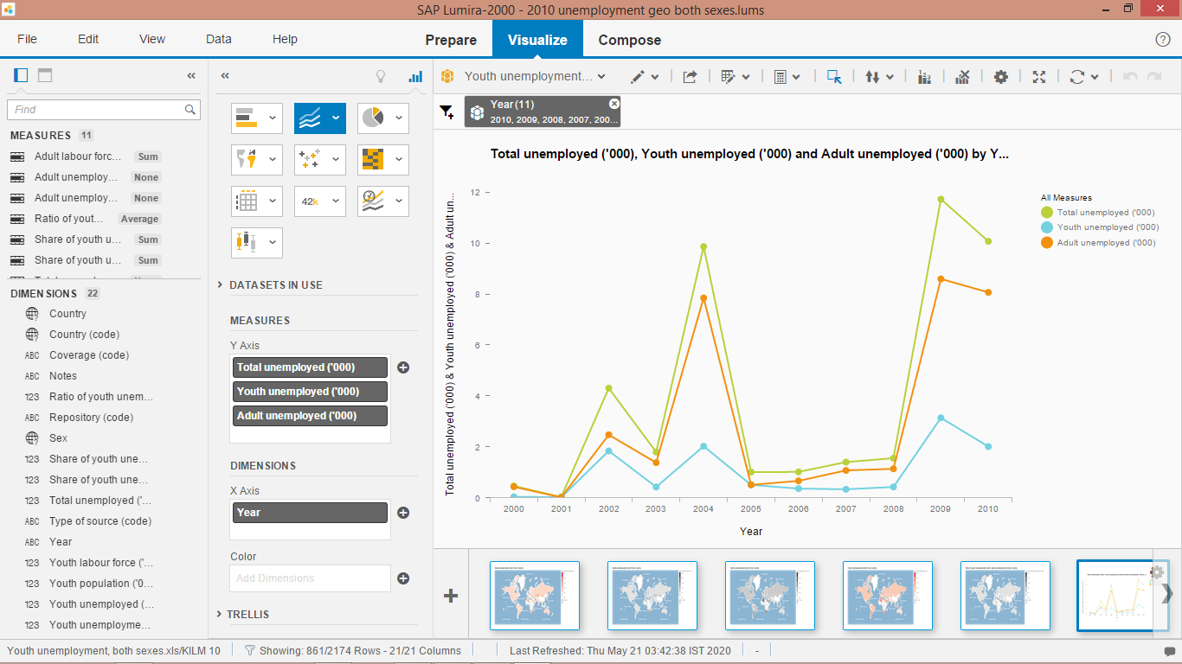

In the above graph, total number of unemployed people, total number of adult unemployed individuals, and total number of youth unemployed individuals are plotted for the decade span of 2000 – 2010 as Green, Red and Blue lines respectively. We see a sharp increase in the level of unemployment after the year of 2008, which can be attributed to the 2008 Financial crisis which significantly impacted the economies of the world.

However, the above graph does not provide a complete picture, we need to find the difference between adult and youth unemployment rates, which can be shown in the following manner:

Figure : Adult Unemployment Rate vs Youth Unemployment Rate (%)

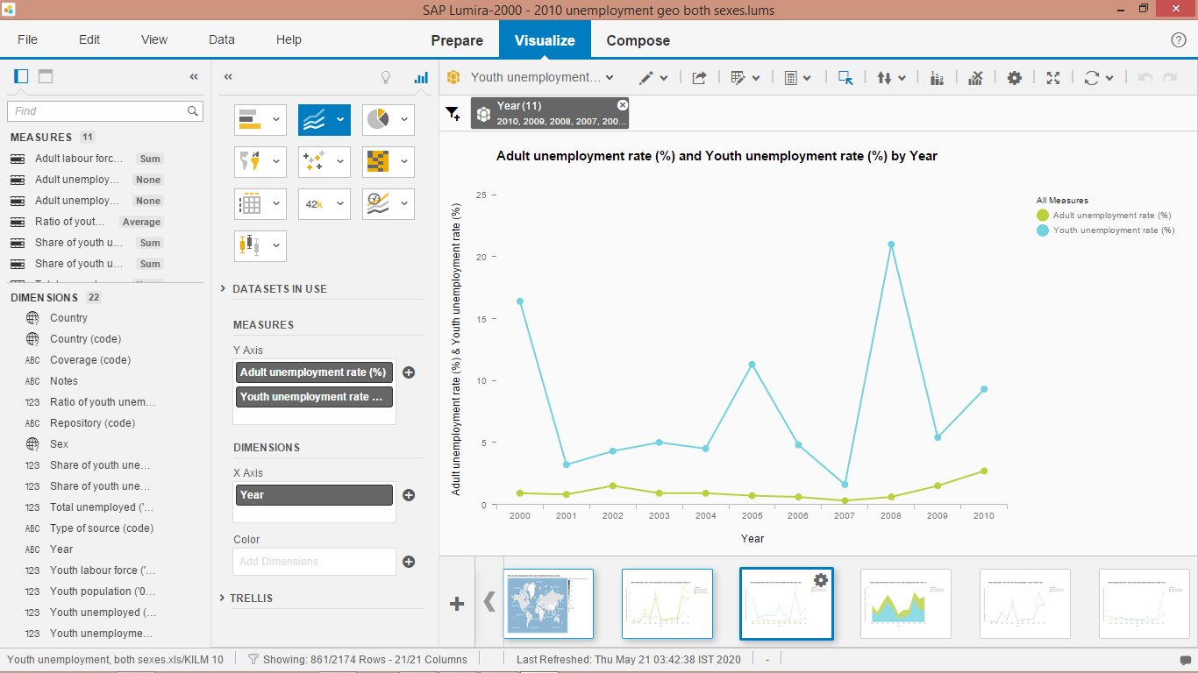

The above graph plots the adult unemployment rates against the youth unemployment rates. This shows that the 2008 Financial crisis affected the youth in a worse manner than the adult labour workforce. As the crisis hit the world, young people and the youth workforce were the first to be out of the jobs. The graph shows that youth unemployment rate reaches 21%, way higher than adult unemployment rate.

### Difference in Unemployment rates between Men and Women

Now that we saw the difference between youth and adult unemployment rates, we focus on the employment trends of men and women. Gender Disparity has existed for many generations, and we have always dreamed of the removal of the same. We see a similar trend in the unemployment levels as well. First, we plot the total number of unemployed individuals for men and women in the following manner:

Figure Total Unemployed (Men) vs Total Unemployed (Women)

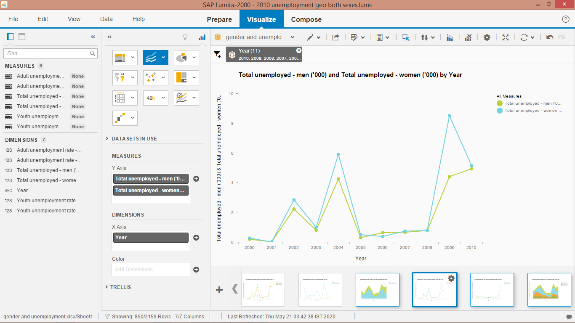

In the above graph, blue line represents the level of unemployed women while green line represents the level of unemployed men. We see that the unemployment levels among women have generally been higher than men in the past decade. To get a complete picture, we now look at adult unemployment rates and youth unemployment rates for both genders:

Figure : Adult Unemployment (Men) vs Adult Unemployment (Women)

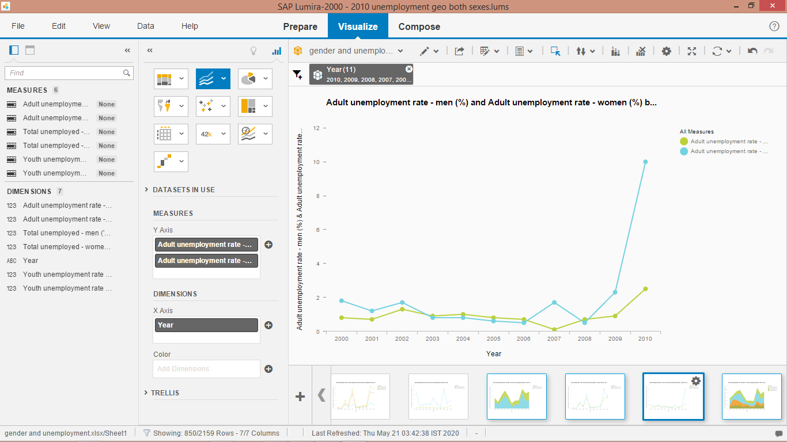

Blue line represents the adult unemployment rates among women, while the green line represents the adult unemployment rates among men. The above graph shows that the 2008 Financial crisis affected women way more than men. The adult unemployment rates for women increased exponentially after the crisis, which shows that more women workers lost their jobs than men.

Figure : Youth Unemployment (Men) vs Youth Unemployment (Women)

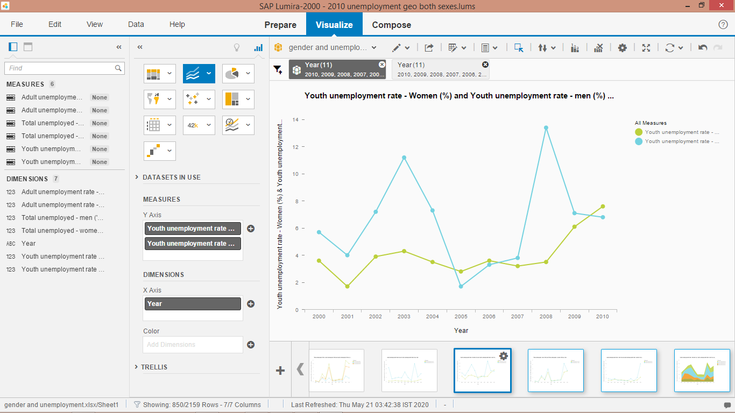

Similarly, the youth unemployment rates for men and women are plotted across the graph.

### Differences in Unemployment Levels among Countries

Finally, we focus on the difference of unemployment levels among various countries of the world. We use the GEO Chorepleth Chart to plot the average unemployment rates of countries in the following manner:

Figure : Adult Unemployment Rates (%) across Various Countries

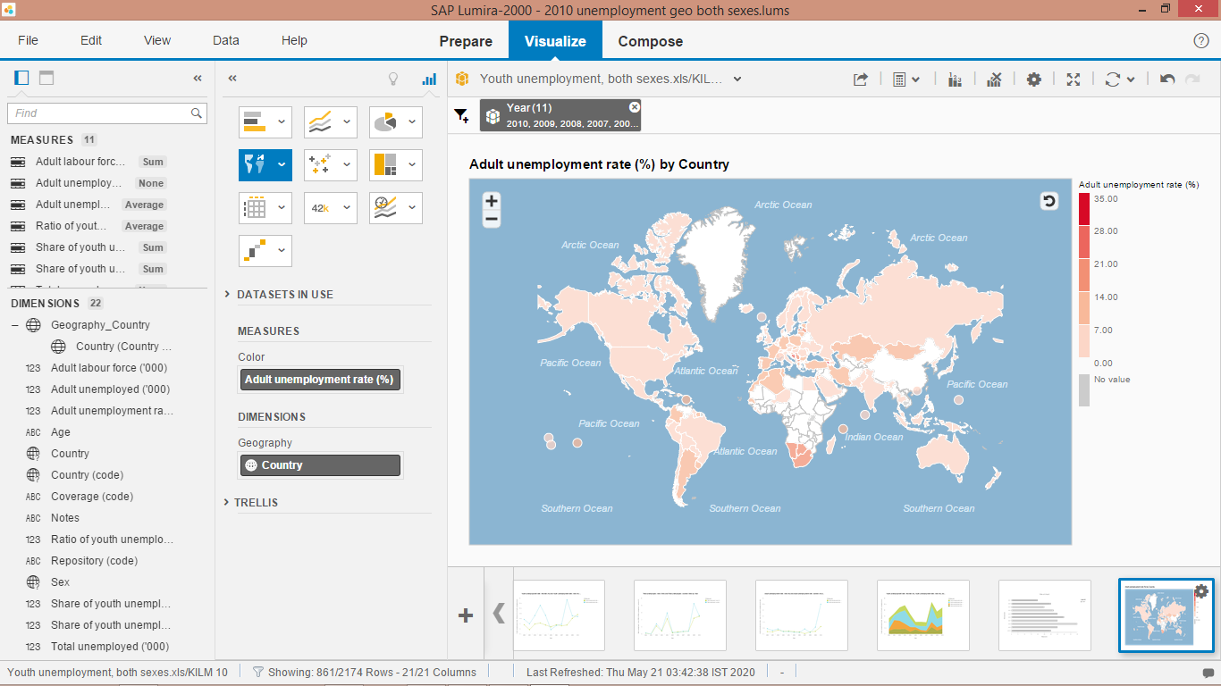

The above map shows the average unemployment rate for each country during the time period. We can see that underdeveloped and developing countries (like South Africa, Mangolia, Kazakhstan, Botswania, etc) suffer from a high unemployment rate than countries like India, Russia, USA, etc.

Figure Adult Unemployment Rates (%) across Countries - Maximum value

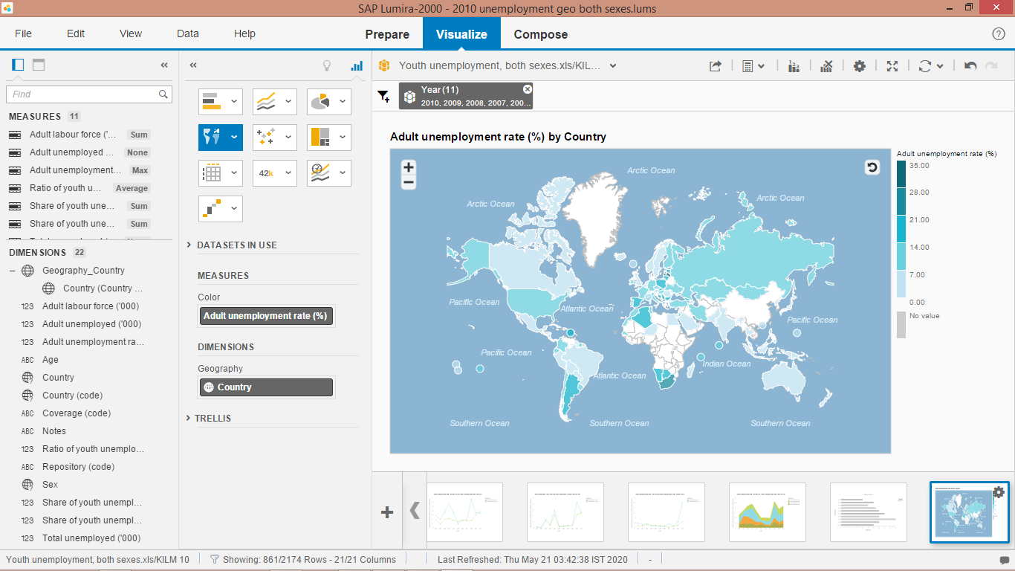

The above graph shows the maximum unemployment rate in the decade for various countries. This graph gives a clearer picture and shows that unemployment rates of even developed countries increased significantly during the decade, wherein US unemployment reached 8.2%, Russia 9%, and so on. Whereas, India remained at 3.5%, mainly because of less dependence on the US economy and less effect of the financial crisis.

In a similar manner, we now look at youth unemployment levels, both average and maximum:

Figure : Youth Unemployment Rates - Average

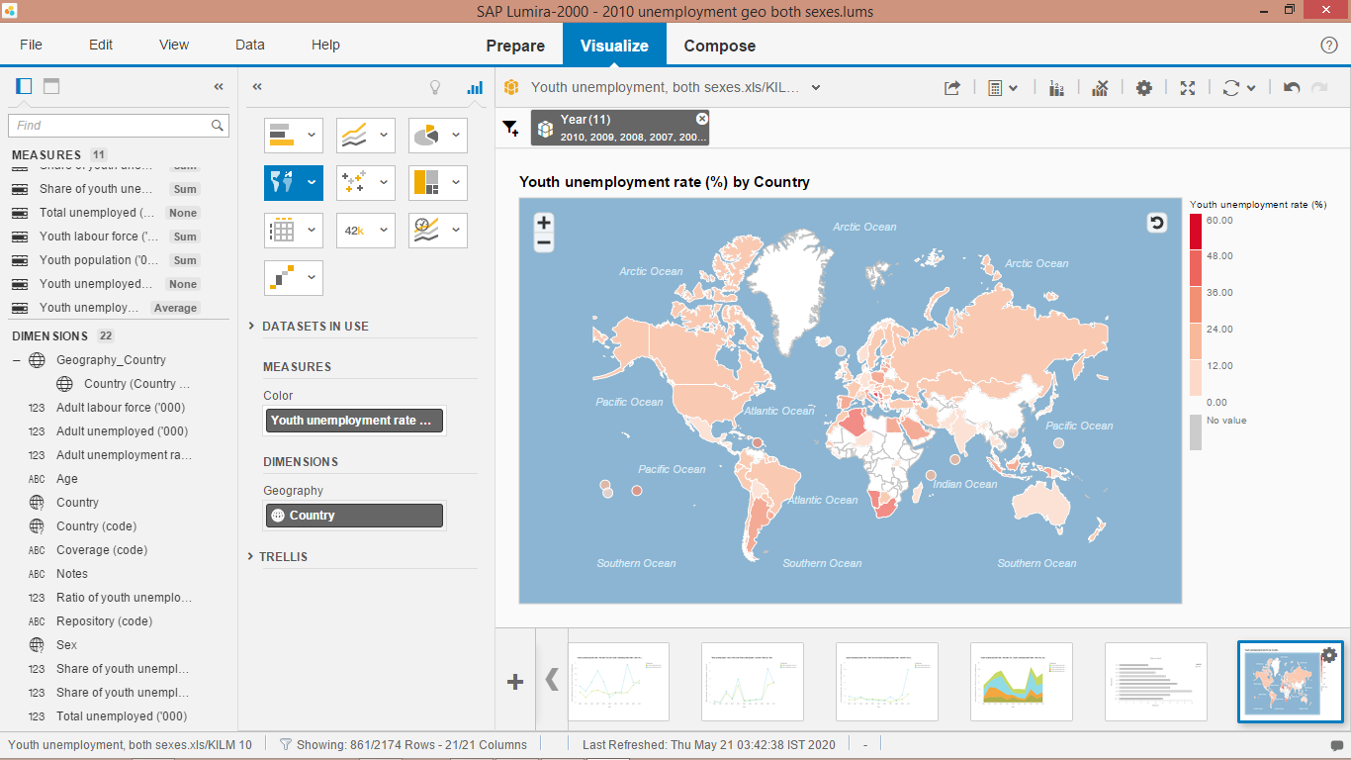

Youth unemployment levels were at a general high level throughout the world, especially in middle eastern countries like Saudi Arabia, Qatar, Egypt, etc. South Africa, Namibia, Argentina and Algeria showed the highest level of average youth unemployment levels ranging from 25 to 40% of the total youth workforce.

Figure : Youth Unemployment Rates - Maximum value

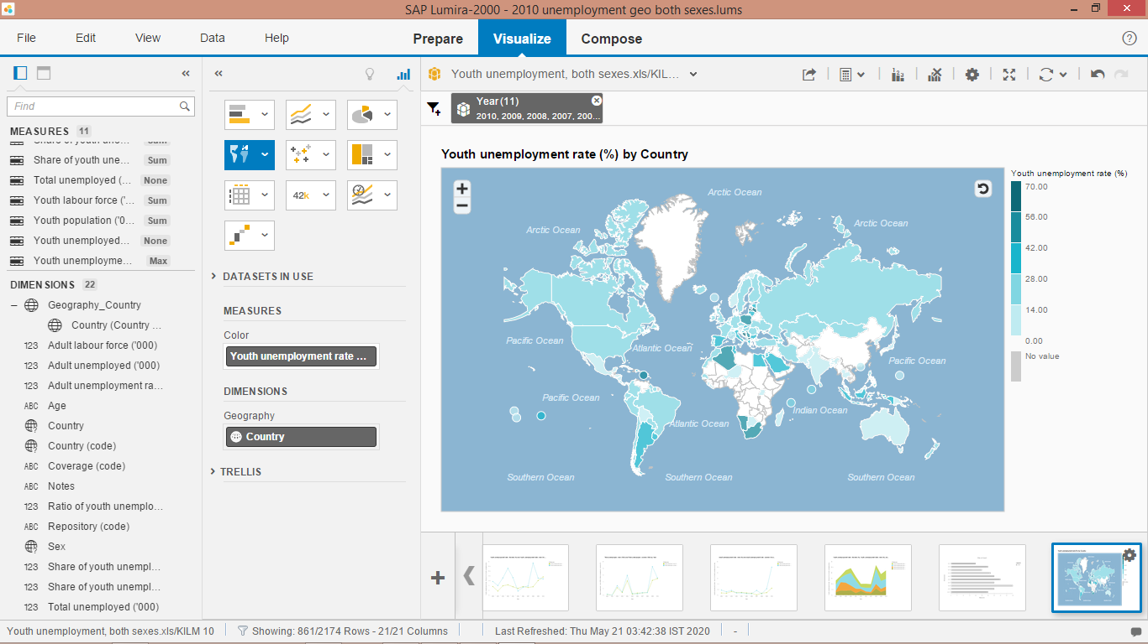

When we plot the maximum youth unemployment rate, we see similar results. Moreover, US, Canada and Russia too seem to have moderate to high unemployment rate, attributing to the financial crisis of 2008.

Finally, we look at the ratio of youth to adult unemployment levels across countries:

Figure : Ratio of Youth Unemployment Rates to Adult Unemployment Rates

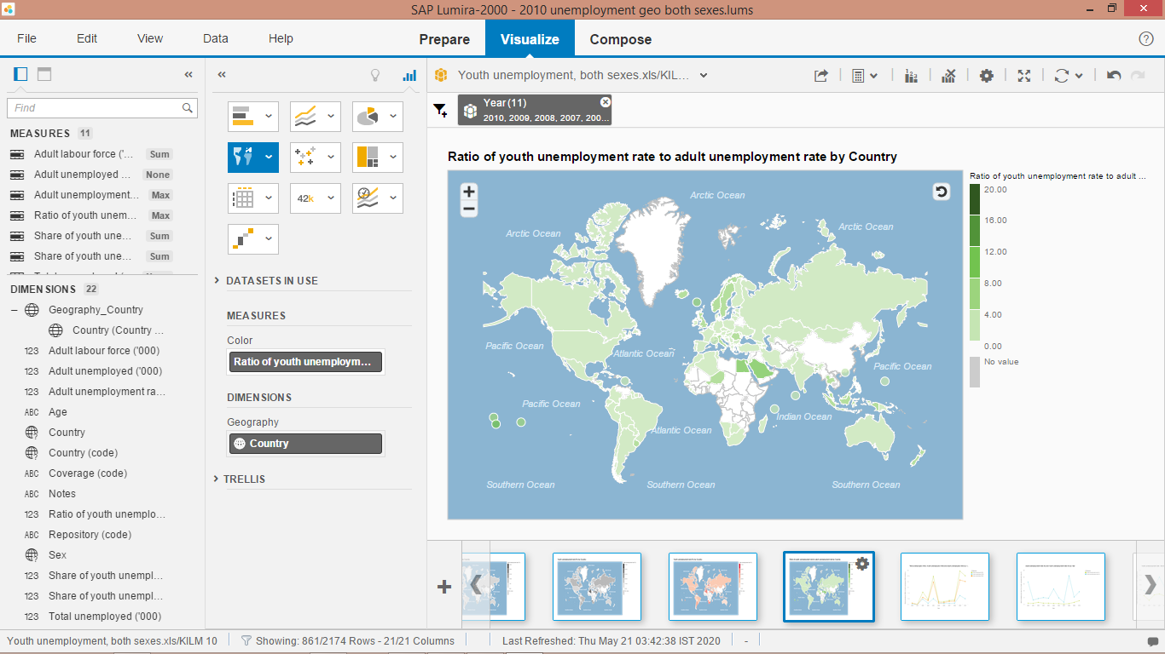

The above map shows that middle eastern countries like Saudi Arabia, Niger, Egypt, and so on, had the highest ratio of youth unemployment to adult unemployment rates.

To have better understanding of the effect of the crisis, we use the following Tree Map:

Figure : Year wise Analysis of Unemployment rates, by ratio of adult to youth unemployment rates

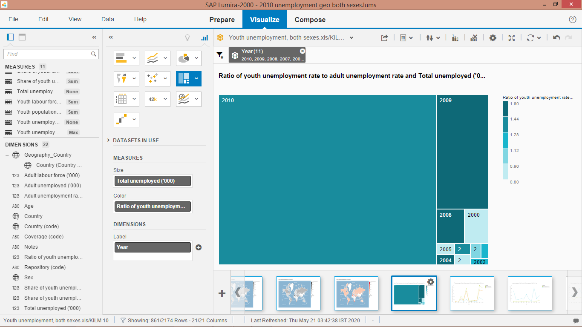

In the above graph, total number of people unemployed determines the size of the box, and the ratio of youth unemployment to adult unemployment determines the colour of the box. It clearly shows that 2010 and 2009 had the highest unemployment levels (2,949,000 and 477,000 respectively), right after the crisis.

## Discussion

Plotting the total number of unemployed individuals, total number of adult unemployed and total number of youth unemployed from 2000 – 2010, we notice a steep rise in the number of unemployed individuals all around the world after 2008. This is attributed to the 2008 Financial Crisis which initiated in The United States and shook financial markets all around the world. This crisis led to millions of people losing jobs and thus leading to high rates of unemployment.

When adult unemployment rates are compared with youth unemployment rates, we find that the youth was affected in a much worse way than adults, as their increase in unemployment rates was exponentially higher than the increase in adult unemployment rates. This shows that the crisis led to more young people losing their jobs than adults.

Similarly, when we plot the unemployment rates for men and women on a graph for the period of 2000 – 2010, we see that the increase in unemployment rates for women was exponentially higher than that of men. This shows that the crisis led to more women losing their jobs than men.

Looking at differences in unemployment rates among different countries, we find that underdeveloped and developing countries had the highest unemployment rates during the period of 2000 – 2010. Countries like South Africa, Namibia, Egypt, were the worst affected by the crisis in terms of level of unemployment, followed by The United States, Canada, Russia.

Lastly, we see that 2010 and 2009 were the worst years and had the highest levels of unemployment.

## Conclusion

Using SAP Lumira to identify and plot unemployment trends helped the researchers extract useful insights. These results can be used as a backbone for the development and implementation of policies. Looking at our findings, we see that the 2008 Financial Crisis significantly impacted the labour force during the years of 2009 and 2010. The unemployment rates for both genders and for both adult and youth workforce sky-rocketed. Women and youth were affected in the worst manner. Another useful finding is that Under developed countries were negatively affected more than the developed countries, especially US, where the Crisis originated. South Africa had extremely high levels of unemployment in 2009, followed by Egypt, Kazakhstan, Saudi Arabia, etc. The report thus provided detailed study into the unemployment trends of 2000 – 2010.

## Recommendations

The report provided conclusive and useful insights about the unemployment trends. Looking at the results, the author would like to present the following recommendations:

1. More focus should be provided towards the employment facilities for youth, since the youth unemployment rates were higher than the adult unemployment rates. Special organisations, services or Quotas should be established which could help in the training and hiring of the young generation.
2. Similarly, Gender Equality is very essential for any economy, both morally and financially. As we saw from the results, more percentage of women were laid off than men. Thus, quotas and organisations need to be set up and better social security schemes need to be provided.
3. Underdeveloped countries are highly unstable. Such economies can collapse or suffer at the slightest change. Thus, Organisations like WTO, UN, etc need to set up funds for the betterment and development for these countries, since unemployment rates were the highest in them.
4. Better social security schemes need to be provided all across the world to help account for such disasters.

## Future Scope for research

The scope of this research was limited due to resource constraints. However, this study could be taken further by taking more recent data of 2011 – 2020 and drawing conclusions for the future as well as the present. Moreover, data on more countries can be obtained.

## References

Klipfolio. (2019, January 5). *Business Intelligence*. Retrieved from Klipfolio.com: https://www.klipfolio.com/resources/articles/what-is-business-intelligence

Pratt, M., & Fruhlinger, J. (2019, October 16). *What is Business Intelligence?* Retrieved from CIO: https://www.cio.com/article/2439504/business-intelligence-definition-and-solutions.html